**Battle of the Neighborhoods Final Report**

Jasmine Li

**1. Introduction**

For the capstone project of Applied Data Science, we are asked to define and solve a real-world problem independently. Objectives of the final assignments are to define a business problem, look for data in the web and, use Foursquare location data to compare different districts within Toronto to figure out which one is suitable for starting an entrepreneurship. As prepared for the assignment, I go through the problem designing, data preparation and final analysis section step by step. Detailed codes and images are given in Github and link can be found at the end of the post.

The idea of this study is to help people planning to open a new restaurant in Toronto to choose the right location by providing data about the income and population of each neighborhood as well as the competitors already present on the same r regions.

**2. Data Preparation**

To provide the stakeholders the necessary information I'll be combining Toronto's 2016 Census that contains Population, Average income per Neighborhood with Foursquare API to collect competitors on the same neighborhoods.

Toronto's Census data in publicly available at this website: <https://www.toronto.ca/city-government/data-research-maps/open-data/open-data-catalogue/#8c732154-5012-9afe-d0cd-ba3ffc813d5a>

A partial view of the dataset is presented as following:

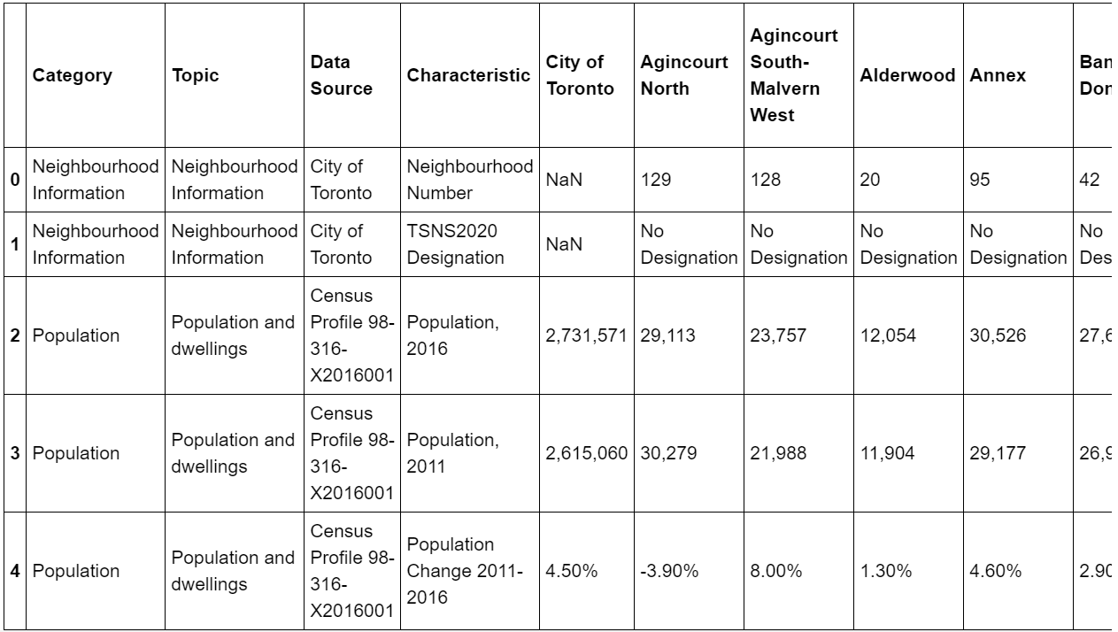

**3. Data Analysis**

First and foremost, we have to conduct data cleaning in order to retrieve the information that we actually need before data analysis. In this project, the focus is on the population and income of the district which are both crucial factors of deciding which location is the optimal choice to start a restaurant.

A partial view of the cleaned dataset is presented as following:

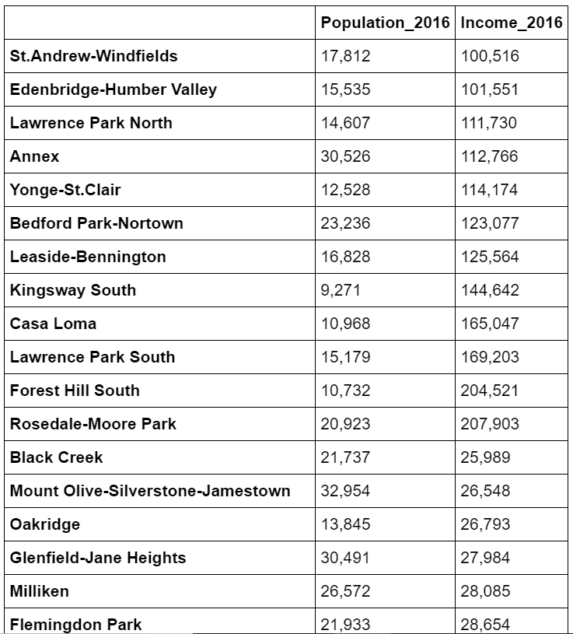

Here is a hot spot map for all the districts in Toronto:

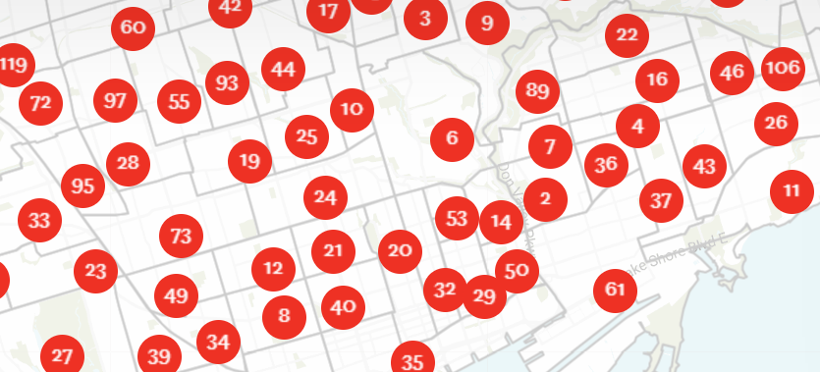

**4. Results and Conclusion**

Based on data analysis, these are the best choices to start a new restaurant in Toronto:

## [Yonge and Eglinton](https://rentals.ca/toronto/yonge-and-eglinton)

Yonge and Eglinton can be called midtown Toronto, but really its on the upper half of midtown. This area has undergone a development boom in the last couple years but even before that, it was a popular place in the city. Iconic bars including the Duke of Kent and Rose and Crown line the streets here, along with pretty much everything else you would need. Medical offices, grocery stores, bars, subway, and great restaurants. It’s ideal for people who want the feel of downtown without being right in the thick of it. Lots of apartment buildings and condos and its uptown location make this one of the more affordable places to live in Toronto. It’s less than a twenty minutes ride to Dundas station and less than twenty minutes to get to the burbs in the other direction.

[**The Annex**](https://rentals.ca/toronto/the-annex)

The Annex is a very student heavy neighborhood but don’t let that scare you off. That just means you have a lot of cheap food options around you, bars with great drink specials, and you’re downtown! The houses in the neighborhood are beautiful and a lot of them are frats and sororities from nearby UFT so if you’re the kind person that misses the Greek scene from unit, The Annex is for you.

[**Kensington Market**](https://rentals.ca/toronto/kensington-market)

Kensington Market may just be my favorite neighborhood in Toronto. Yes you have to take a street car if you don’t like to walk but it is so worth it. The houses are unique and gorgeous, it has some of the best food in the city, the community is full of quirky personality, and China town is right there to meet all of your shopping needs. Not enough people appreciate the kind of shopping you can do in China town. The prices are cheap and you can get all kinds of groceries. Also, dumplings, delicious dumplings on every corner. The business in the market features quaint cafes, little fruit and veg markets, amazing ethnic food, and vintage hippie shops. Kensington is just a dream come true in Toronto. A good way to gage if Kensington is right for you is one simple question, do you like incense? If yes Kensington will probably make you very happy.

**Queen St. West**

Queen St. West is one of the most fun streets to walk down. You can plan to do some of the best shopping in the city, drink at some of the most popular bars, and eat some great food all while walking along this one street. It is one of, if not the coolest neighborhood in Toronto. There are stores to meet every fashion style from super chic to punk.  Definitely one of the busiest neighborhoods in Toronto with a whole lot to offer in the way of excitement.